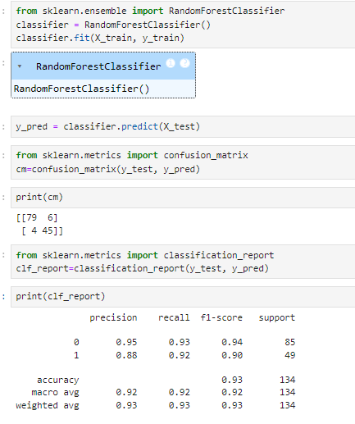

From Dataset:

Total count in the test set: 134

Total count of Purchased in the test set: 85

Total count of Not purchased in the test set: 49

From algorithm:

|  |  |  |
| --- | --- | --- |
|  | Purchased | Not purchased |
| Purchased | 79 (True purchased) | 6 (False purchased) |
| Not purchased | 4 (False not purchased) | 45 (True not purchased) |

**1)Accuracy:**

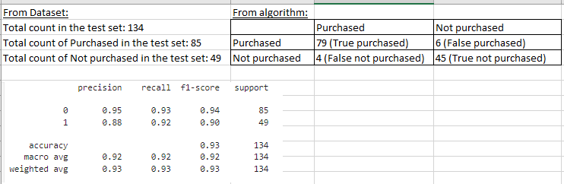

What is the percentage of correct classification of both Purchased and Not purchased to the total input of the test set?

Formula:

T(Purchased)+T(Not purchased)

--------------------------------------------------------------------------------------

T(Purchased)+T(Not purchased)+ F(Purchased)+F(Not purchased)

Therefore,

79+45 124

-------------- = ------------ **= 0.925**

79+45+6+4 134

**2) Purchased precision:**



What is the percentage of correct classification of Purchased to sum of correctly classified as Purchased and wrongly classified as Purchased in the test set?

T(Purchased)

------------------------------------------

T(Purchased)+F(Not purchased)

79/79+4 = 79/83= **0.951**

**3)Not purchased precision:**



What is the percentage of correct classification of Not Purchased to sum of correctly classified as Not Purchased and wrongly classified as Not Purchased in the test set?

T(Not Purchased)

------------------------------------------

T(Not Purchased)+F(Purchased)

45/45+6 = 45/51= **0.882**

**4) Purchased Recall:**



What is the percentage of correct classification of Purchased to the total input of Purchased in the test set?

T(Purchased)

------------------------------------------

T(Purchased)+F(Purchased)

79/79+6 = 79/85= **0.929**

**5)Not purchased Recall:**



What is the percentage of correct classification of Not Purchased to the total input of Not Purchased in the test set?

T(Not Purchased)

------------------------------------------

T(Not Purchased)+F(Not Purchased)

45/45+4 = 45/49= **0.918**

**6) Purchased F1 Score:**



What is the overall performance of Purchased?

Recall * Precision 0.93*0.95

2 * ------------------------------------------ = 2 * ------------- = **0.939**

Recall + Precision 0.93+0.95

**7)Not purchased F1 Score:**



What is the overall performance of Not Purchased?

Recall * Precision 0.92*0.88

2 * ------------------------------------------ = 2 * ------------- = **0.899**

Recall + Precision 0.92+0.88

**8)Macro Average – Precision:**



What is the average performance of Precision (correctly and wrongly classified)

Precision (Purchased) + Precision (Not Purchased)/ 2 = 0.95+ 0.88/2 = **0.915**

**9)Macro Average – Recall:**



What is the average performance of Recall (correctly classified)

Recall (Purchased) + Recall (Not purchased) /2 = 0.93+0.92/2= **0.925**

**10)Macro Average – F1 Score:**



What is the average performance of F1 score (overall performance)

F1 (Purchased) + F1 (Not purchased)/2 = 0.94+ 0.90/2 = **0.92**

**11)Weighted Average – Precision:**



What is the sum of product of proportion rate (weight) of each class?

{Precision (Purchased)* Total (P)/Total (P+NP)} + {Precision (Not Purchased)* Total (NP)/Total (P+NP)}

{0.95*85/134} + {0.88*49/134}

0.602+0.321=0.923

**12)Weighted Average – Recall:**



What is the sum of product of proportion rate (weight) of each class?

{Recall (Purchased)* Total (P)/Total (P+NP)} + {Recall (Not Purchased)* Total (NP)/Total (P+NP)}

{0.93*85/134} + {0.92*49/134}

0.589+0.336=0.925

**13)Weighted Average – F1 measure:**



What is the sum of product of proportion rate (weight) of each class?

{F1 (Purchased)* Total (P)/Total (P+NP)} + {F1 (Not Purchased)* Total (NP)/Total (P+NP)}

{0.94*85/134} + {0.90*49/134}

0.596+0.329=0.925